Setup av Router-01. Switch-01, Switch-02, subnet /26 och VLAN 10, 20,30,99

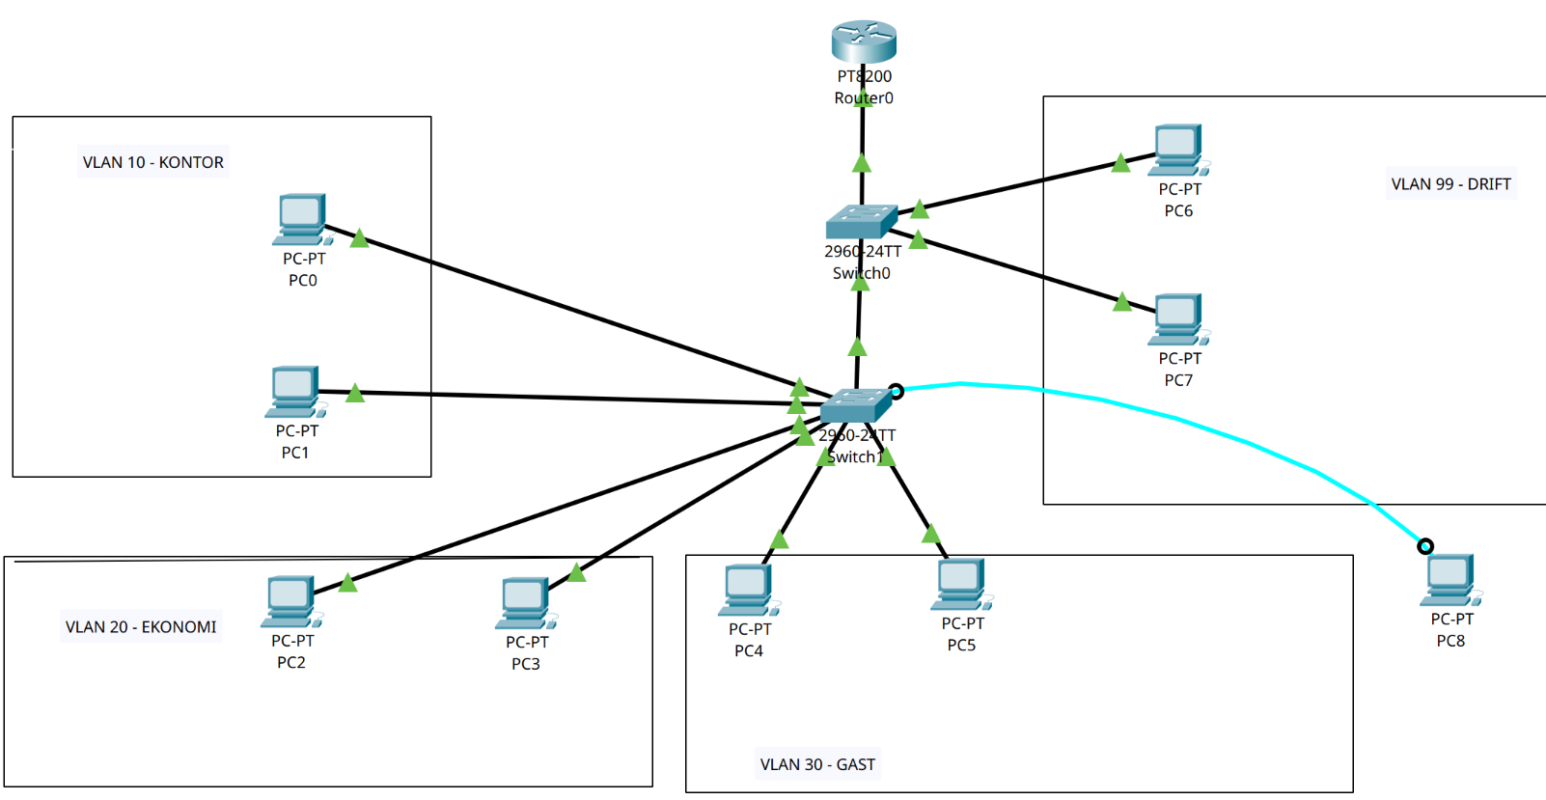

1. Definiera alla nätverk

1. Kontor – vlan 10
2. Ekonomi – vlan 20
3. Gast – vlan 30
4. Drift – vlan 99

Kontor Network: 192.168.1.0, Router: 192.168.1.1
Ekonomi Network: 192.168.1.64, Router: 192.168.1.65
Gast Network: 192.168.1.128, Router: 192.168.1.129
Drift network: 192.168.1.192, Router: 192.168.1.193

Varje network vill ha 10 reserverad address till statik enheter.

Kontor Network excluded-address 192.168.1.2 192.168.1.11
Ekonomi Network excluded-address 192.168.1.66 192.168.1.75
Gast Network excluded-address 192.168.1.130 192.168.1.139
Drift network excluded-address 192.168.1.194 192.168.1.203

1. Router setup

Byta Hostname och bestämmer vlans på interface

Enable
conf t
Hostname RT-01-Attila
int g0/0/0
no shutdown
end
write

Fix alla vlan på router G0/0/0 port

int g0/0/0
no ip address

int g0/0/0.10
encapsulation dot1q 10
ip address 192.168.1.1 255.255.255.192

int g0/0/0.20
encapsulation dot1q 20
ip address 192.168.1.65 255.255.255.192

int g0/0/0.30
encapsulation dot1q 30
192.168.1.129 255.255.255.192

int g0/0/0.99
encapsulation dot1q 99
192.168.1.193 255.255.255.192

ip dhcp excluded-address 192.168.1.2 192.168.1.11
ip dhcp excluded-address 192.168.1.66 192.168.1.75
ip dhcp excluded-address 192.168.1.130 192.168.1.139
ip dhcp excluded-address 192.168.1.194 192.168.1.203

ip dhcp pool Kontor

192.168.1.0 255.255.255.192
default-router 192.168.1.1
dns-server 8.8.8.8

ip dhcp pool Ekonomi

192.168.1.64 255.255.255.192
default-router 192.168.1.65
dns-server 8.8.8.8

ip dhcp pool Gast

192.168.1.128 255.255.255.192
default-router 192.168.1.129
dns-server 8.8.8.8

ip dhcp pool Drift

192.168.1.192 255.255.255.192
default-router 192.168.1.193
dns-server 8.8.8.8

2. switch 0 setup

enable
conf t
Hostname SW-01-Attila

vlan 10
name KONTOR

vlan 20
name EKONOMI

vlan 30
name GAST

vlan 99
name DRIFT

int G0/1 switchport mode trunk
switchport trunk allowed vlan 10,20,30,99
switchport native vlan 999

int g0/2 switchport mode trunk
switchport trunk allowed vlan 10,20,30,99
switchport native vlan 999

PC 6 - DRIFT
int f0/1
switchport mode access
switchport access vlan 99

PC7 -DRIFT
int f0/2
switchport mode access
switchport access vlan 99

3. Switch 2 setup

enable
conf t
Hostname SW-01-Attila

vlan 10
name KONTOR

vlan 20
name EKONOMI

vlan 30
name GAST

vlan 99
name DRIFT

Pc 0 och Pc 1 – VLAN 10 - KONTOR

interface fa0/1
switchport mode access
switchport access vlan 10

interface fa0/2
switchport mode access
switchport access vlan 10

Pc 2 och Pc 3 - VLAN 20 – EKONOMI

interface fa0/3
switchport mode access
switchport access vlan 20

Interface fa0/4
switchport mode access
switchport access vlan 20

Pc 4 och Pc 5 – VLAN 30 – GAST

int fa0/5
switchport mode access
switchport access vlan 30

int fa0/6
switchport mode access
switchport access vlan 30

Check on both switch om vlans and trunk ports are working.

Show vlan brief
show interfaces trunk

